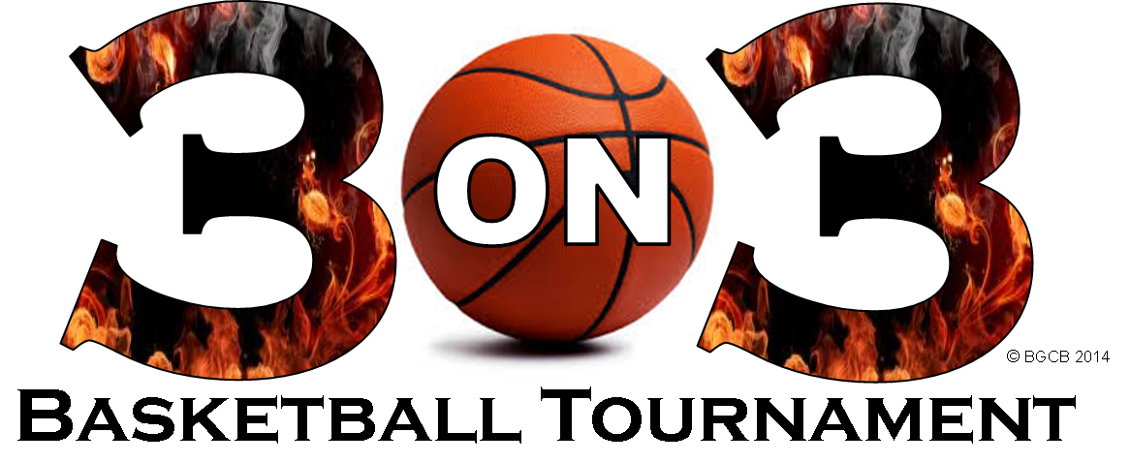
Washington Irving 4th/5th Grade 3-on-3 Basketball Tournament

Saturday, April 6, 2019 @ 9:00 AM

Participants: 4th & 5th Grade IRVING STUDENTS

Teams: 4th and 5th Grade Boys
4th and 5th Grade Girls
4th and 5th Grade Co-Ed (bracket will be determined by registration)
3 to 4 players per team (Irving Only)

Entry: $5.00 per player / Scholarships Available

Registration Form

Team Name: _________________________________________
Team Captain: _________________________________________

Player #1: _______________________________________________________________
Shirt size: _____________________

Player #2: _______________________________________________________________
Shirt size: _____________________

Player #3: _______________________________________________________________
Shirt size: _____________________

Player #4: ________________________________________________________________
Shirt size: _____________________

Make Checks Payable to IRVING PTO

Return Forms to Mr. Hancock at jhancock@op97.org
or Mr. DiPaolo at fdipaolo@op97.org.

