Irving’s Turkey Trot

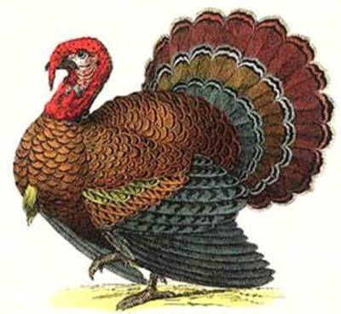

When- Thursday November 21st at 2:00pm

Where- Around the school

Who- 3rd-5th grades

Why- To help promote fitness and wellness in our the upper grades

