READING OLYMPICS T-SHIRT ORDER FORM

Get ready for the Oak Park River Forest Reading Olympics!

We have created this T-shirt for all kids, teachers, librarians and staff that are competing, organizing or just enamored with Reading Olympics (or just want a really cool T-Shirt!).
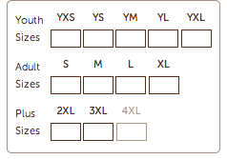

The price for each shirt is $12.00. T-shirt purchase is optional.


Total Payment: ___________

All forms and payment must be submitted to
Ms. Noonan by
November 12th.
Checks should be made out to Irving PTO.

Participating school or library

___________________________________________

Student/Teacher/Staff Name

___________________________________________

Student – homeroom (if applicable)

___________________________________________

Contact email ________________________________

Enter Quantities Below:

