Get your Irving Yearbook!
$15 each (Cash or check to Irving PTO)
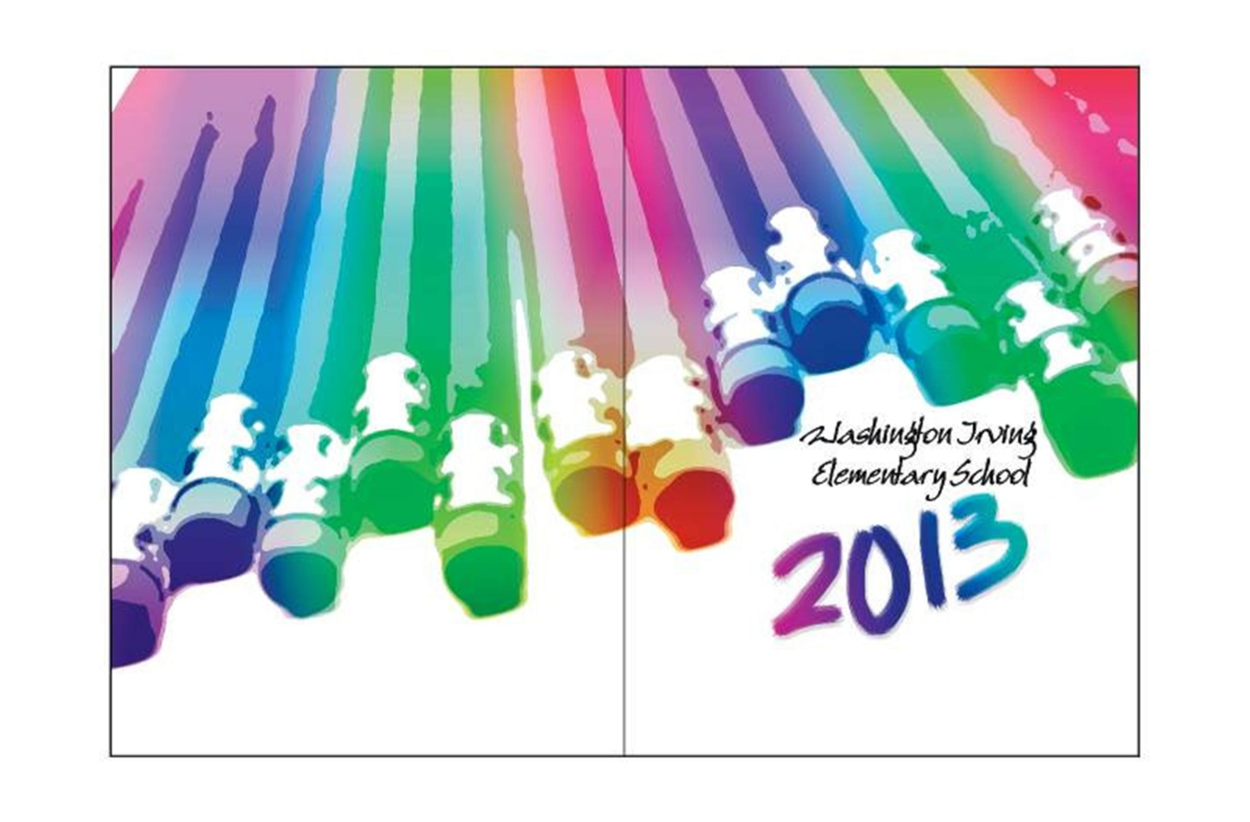
After school near the office
Wednesday, May 15
& Friday, May 17
(And then will be for sale in the office.)

