ORDER YOUR IRVING BASEBALL T-SHIRT BY JANUARY 27TH!
3/4 –SLEEVE, PRE-SHRUNK, 100% COTTON
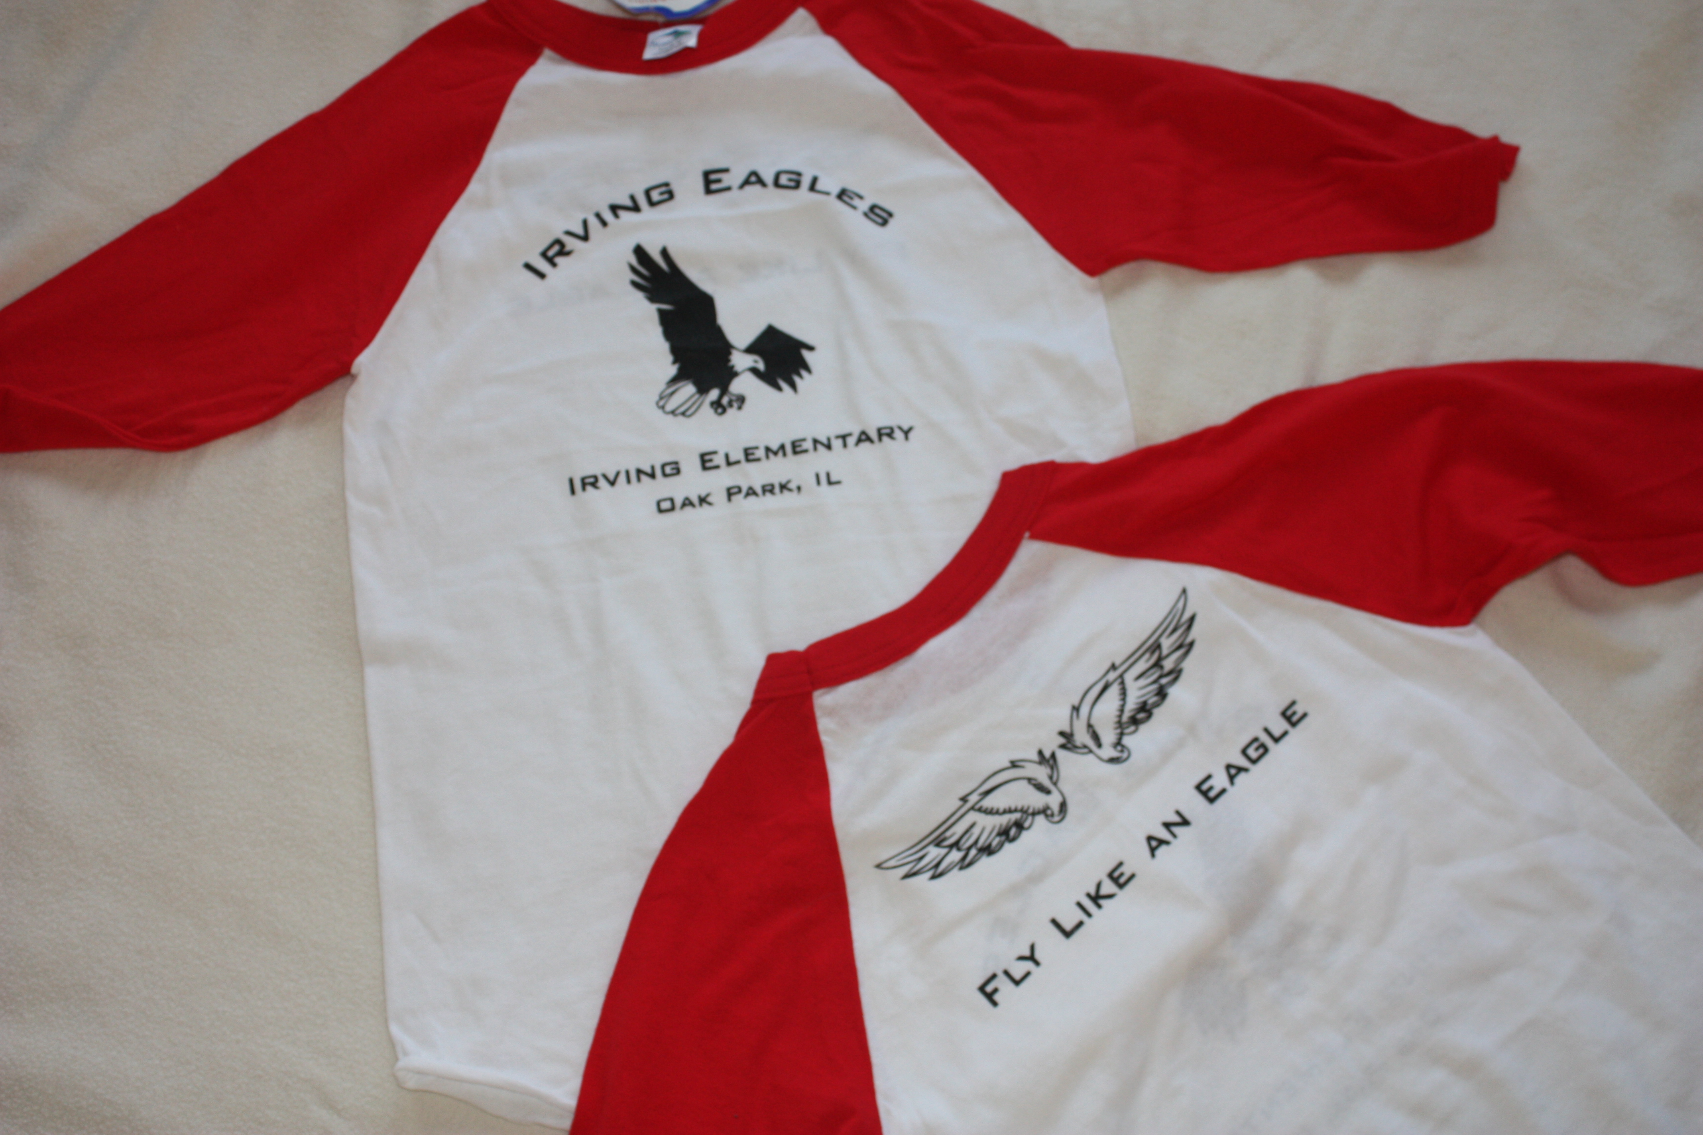
AVAILABLE IN YOUTH SIZES SMALL-LARGE &
ADULT SIZES SMALL- XXX-LARGE
ALL SIZES JUST $15

Name: ______________________________________________________________
Grade/Teacher_______________________________________________________
Youth Sizes: S M L Adult Sizes: S M L XL XXL XXXL
Email_________________________________________________________________
Return Order Form & Payment of Cash or Check Payable to Irving PTO
Any questions? Contact Emily Novak: enovak3@yahoo.com

