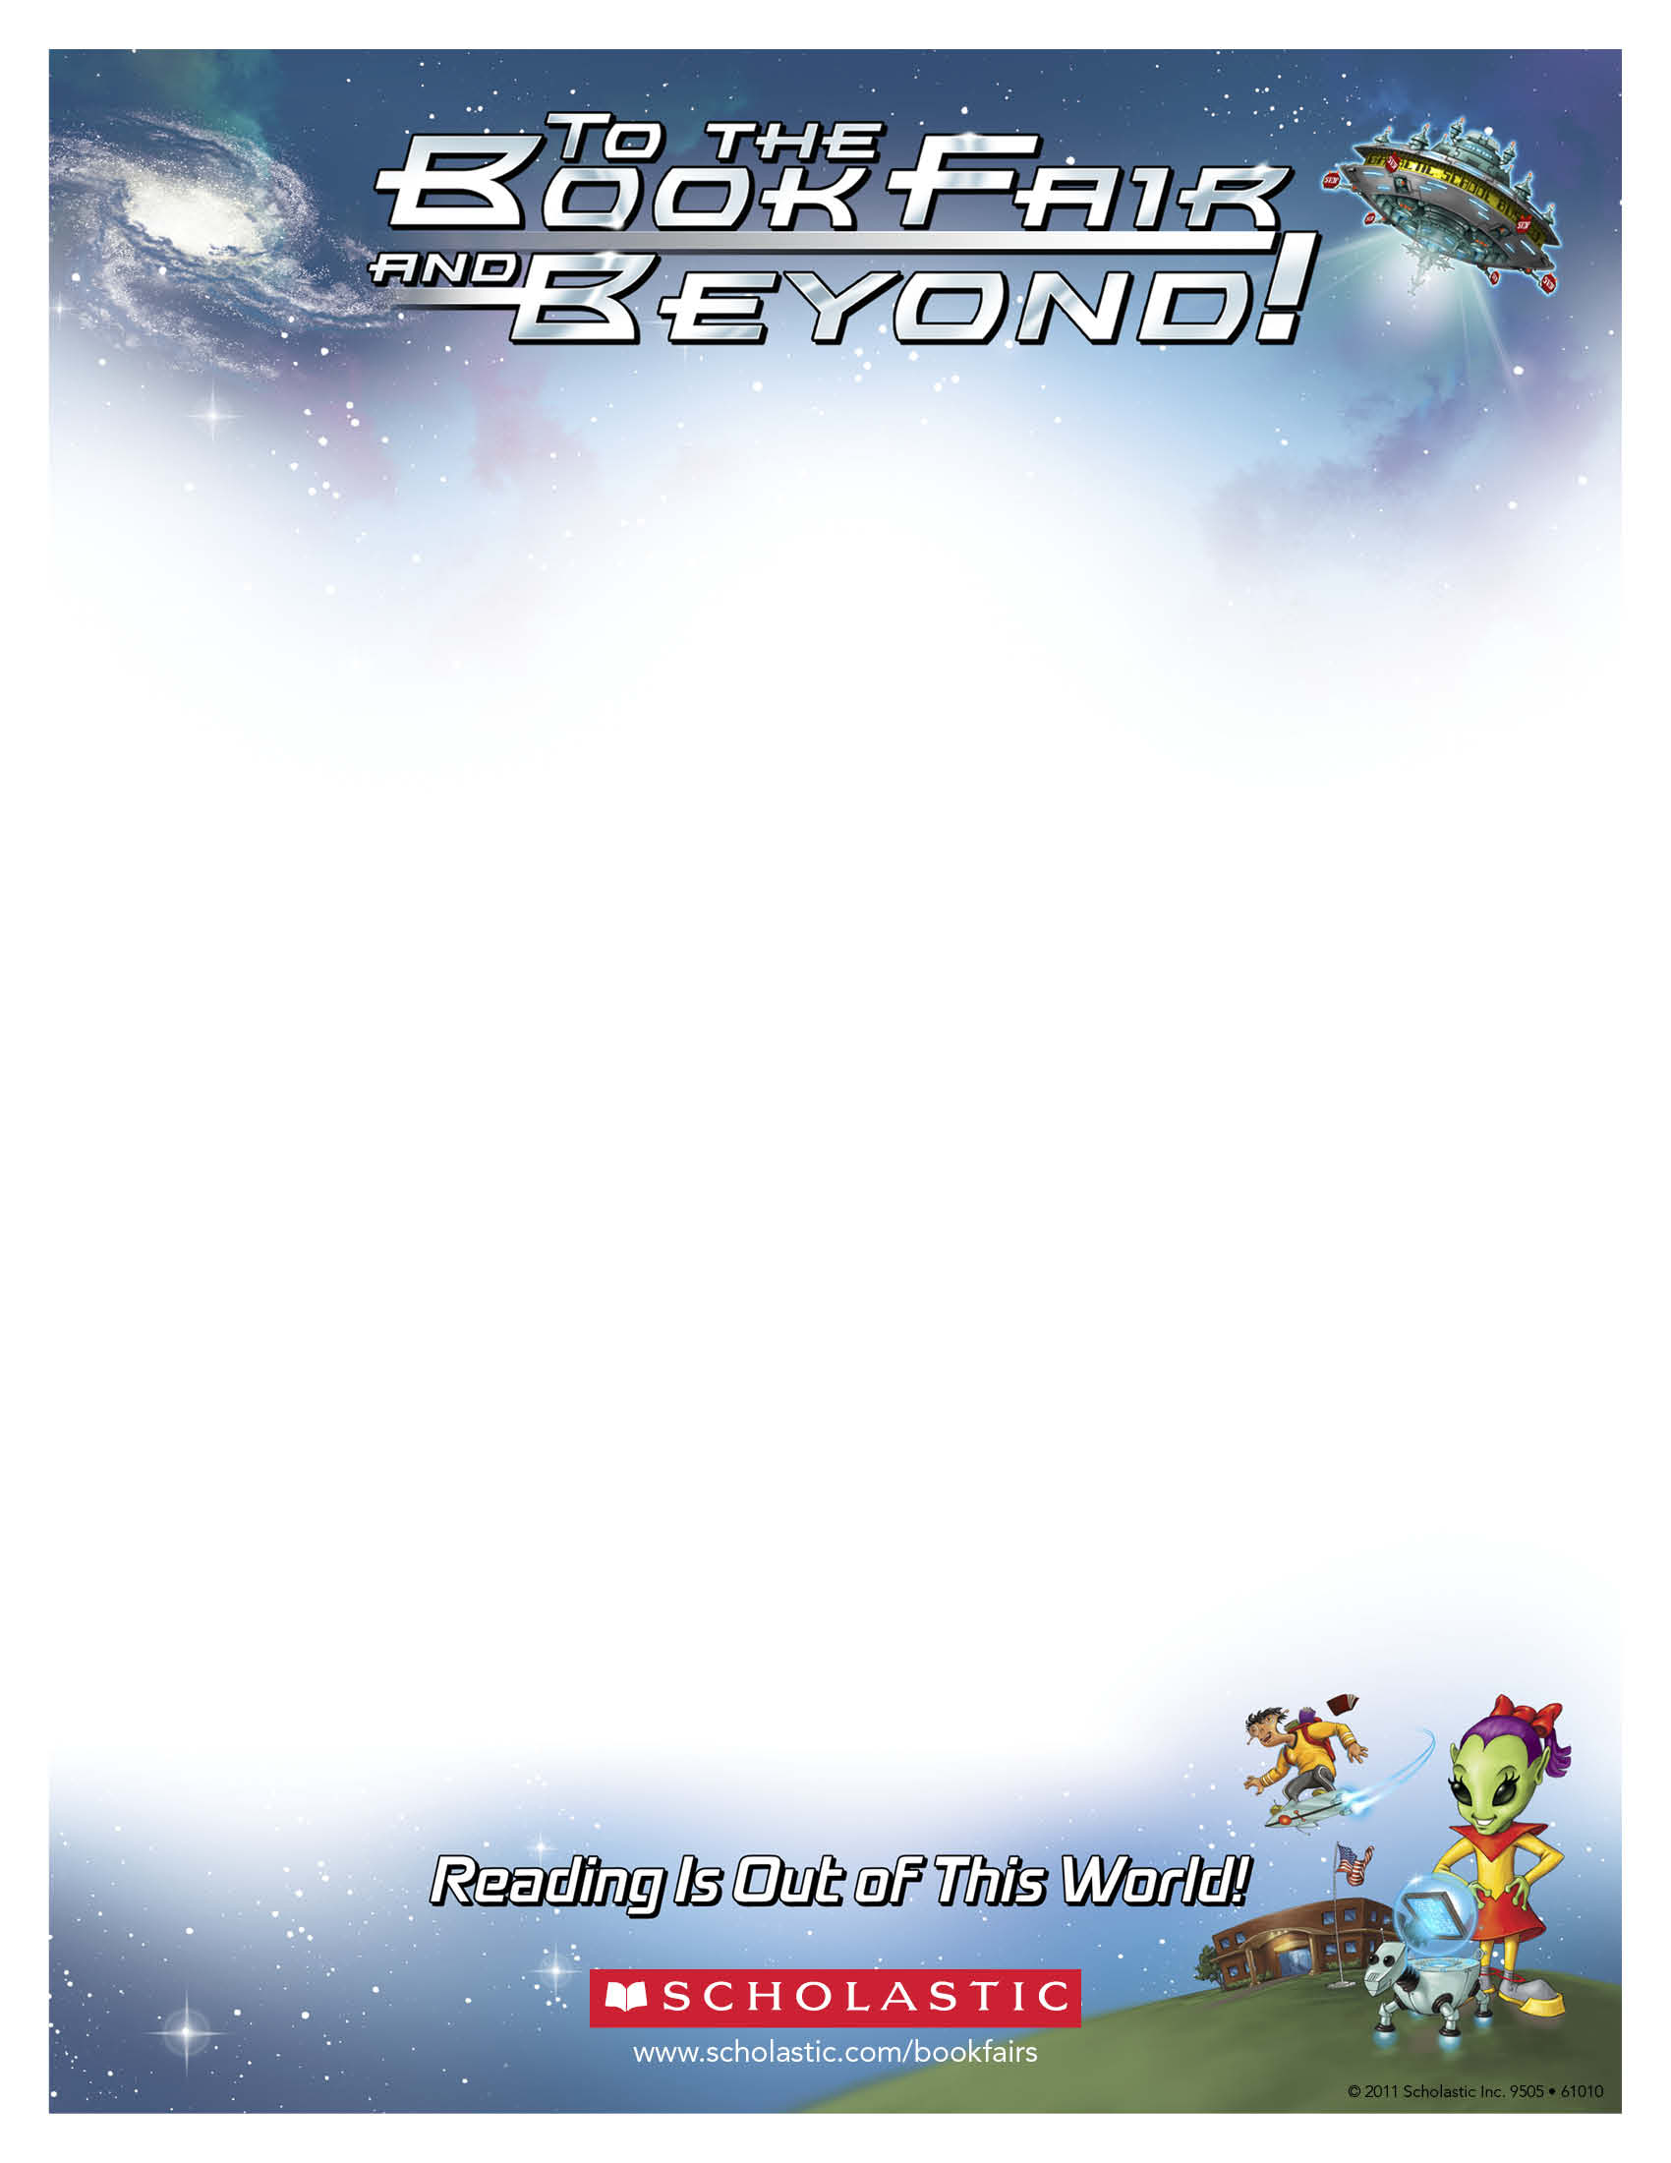
Dear Parents and Families:

Reading is the most important skill you can teach a child. Of all the skills children learn, it is the one you can influence the most.

We invite you to visit our Scholastic Book Fair and experience a celebration of reading that provides families the opportunity to get involved in a universal mission: encouraging kids to read every day so they can lead better lives.

Our Scholastic Book Fair theme – To the Book Fair and Beyond! – is part of an out-of-this-world reading event that brings to school a wonderful selection of fun, engaging, and affordable books kids want to read. Giving kids access to good books and the opportunity to choose their own books will motivate them to read more. And like most acquired skills, the more kids practice reading, the better they’ll get.

Last fall we sold over 1,200 books which was an amazing feat! This year we are hoping to sell over 1,400 books - - all sales will help support our Library and Media Center.

Book Fair Dates: October 17 – 21 – every day after dismissal until 6:30 pm
Parent preview: Monday, October 17 – 8:00 – 8:30 am
Location: Irving Auditorium

I hope to see you at the Book Fair!

John Hodge
Principal

